**Runnable Jars creation**

create new package and new class inside src/test/java of the Project.

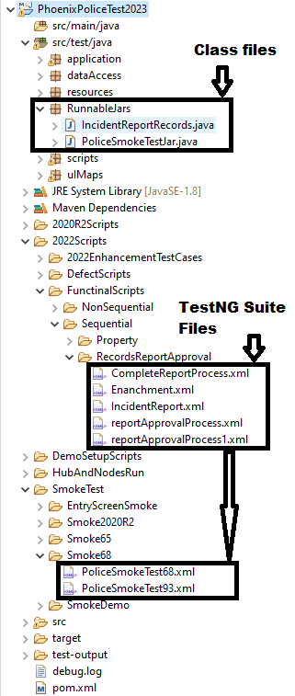

create class and include below code with suite file name.

Code :

**public** **class** PoliceSmokeTestJar {

**public** **static** **void** main(String[] args) {

TestNG test = **new** TestNG();

String xmlIncident = "suitefilepath";

List<String> lsXML = **new** ArrayList<String>();

lsXML.add(xmlIncident);

test.setTestSuites(lsXML);

test.run();

}

}

Note : Build project and run and Verify program whether it will trigger scripts

**To create jar files, proceed with next steps …**

Create one Folder on Desktop as RunnableJars and Add below Folder structure

* Inside Drivers keep latest version of chromedriver.exe.
* Inside Jsons Keep all the latest Json data files.
* Inside resources keep updated config.properties.
* RunResultExtent for collecting extent reports.
* Test-output flushes the TestNG reports.

Go to resources Package of the Project from Eclipse and map Config properties file which we are having inside runnable jars folder.

Change read properties file path. Save all the files and build project.

Save and Build project.

then

Right click on project and click on export option.

Select java -> Runnable JAR file and click on next.

Select Launcher Application same as class name and add export destination with file name click on finish.

Click on popup message.

Export process initiated wait for while and click on Finish and check Jar have been generated.

In Destination folder

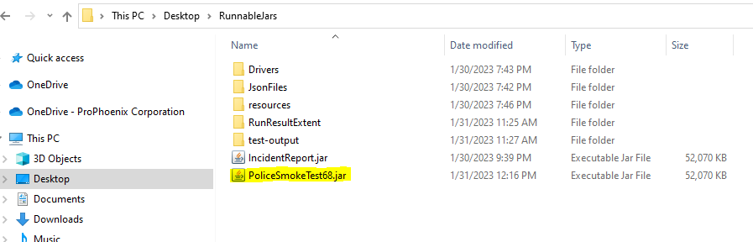

Double click on Jar file it will trigger scripts.

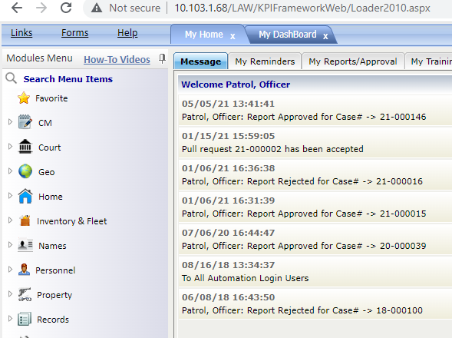

Run Jar file from cmd

Go to the folder where we have Jar files and type cmd click enter

Use below commond to trigger jar file

**Java -jar jarfilename.jar** click enter

Let scripts to complete after completing.

Review TestNG reports from test-output

Review Extent reports from Run Result extent

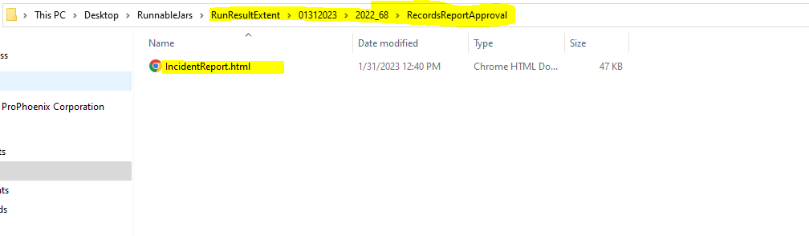

Thank you..